POE Part 2

# My application

This is the second part of my POE. While still containing the functions from part one there were some add ons. These add ones included adding as many recipes as the users wants, adding a recipe name, allowing the users to add ingredient calories and food groups, and displaying the recipes in a list so that the user can select which one to view.

Once you run the program you are presented with option to either add, view or adjust a recipe. You are also presented with the option to exit the program from the main menu. If you select add, you are taken to a method called Recipes. Here you will add recipe name, ingredients, quantities, units of measurement, calories, and food groups. This information is all stored in a generic collection list. You are then taken back to the main menu where you can either select to add another recipe, adjust the recipe you have added or view the recipe you have added.

If the option view is selected, the program will provide a list of recipes you have added. You have to choose which recipe to use. Whichever one you choose will be displayed to you. If the total calories of the program is greater than 300, a warning will be displayed to you. From here you are taken back to the main menu.

If adjust is chosen, you will have to select from the list of recipes you have added which one you want to adjust. You can choose to clear that recipe, double, half or triple the quantities of the recipe. The newly adjusted recipe will be displayed to you and then you will be taken back to the main menu. This program will continue to loop until you decide to finish and exit the program.

# Improvements I made to my POE PART 3:

From the feedback I received from the lecturer, marks were deducted for not including delegations in my part 2. The other issue was that there was not a unit testing method for calories. While implementing the delegation I also included a unit testing method to give out a warning if the total number of calories exceeds 300.



Figure : delegation

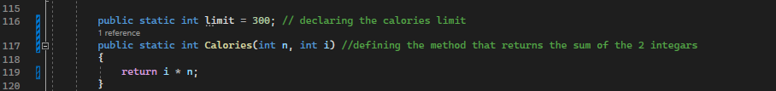

Figure : method for delegation

Figure : delegation and unit testing

Link to GitHub repository

Github classroom: https://github.com/IIEMSA/prog6221-part2-Rue-ru.git

GitHub source code link: https://github.com/Rue-ru/POE_PART3.git

# Commits Screenshot

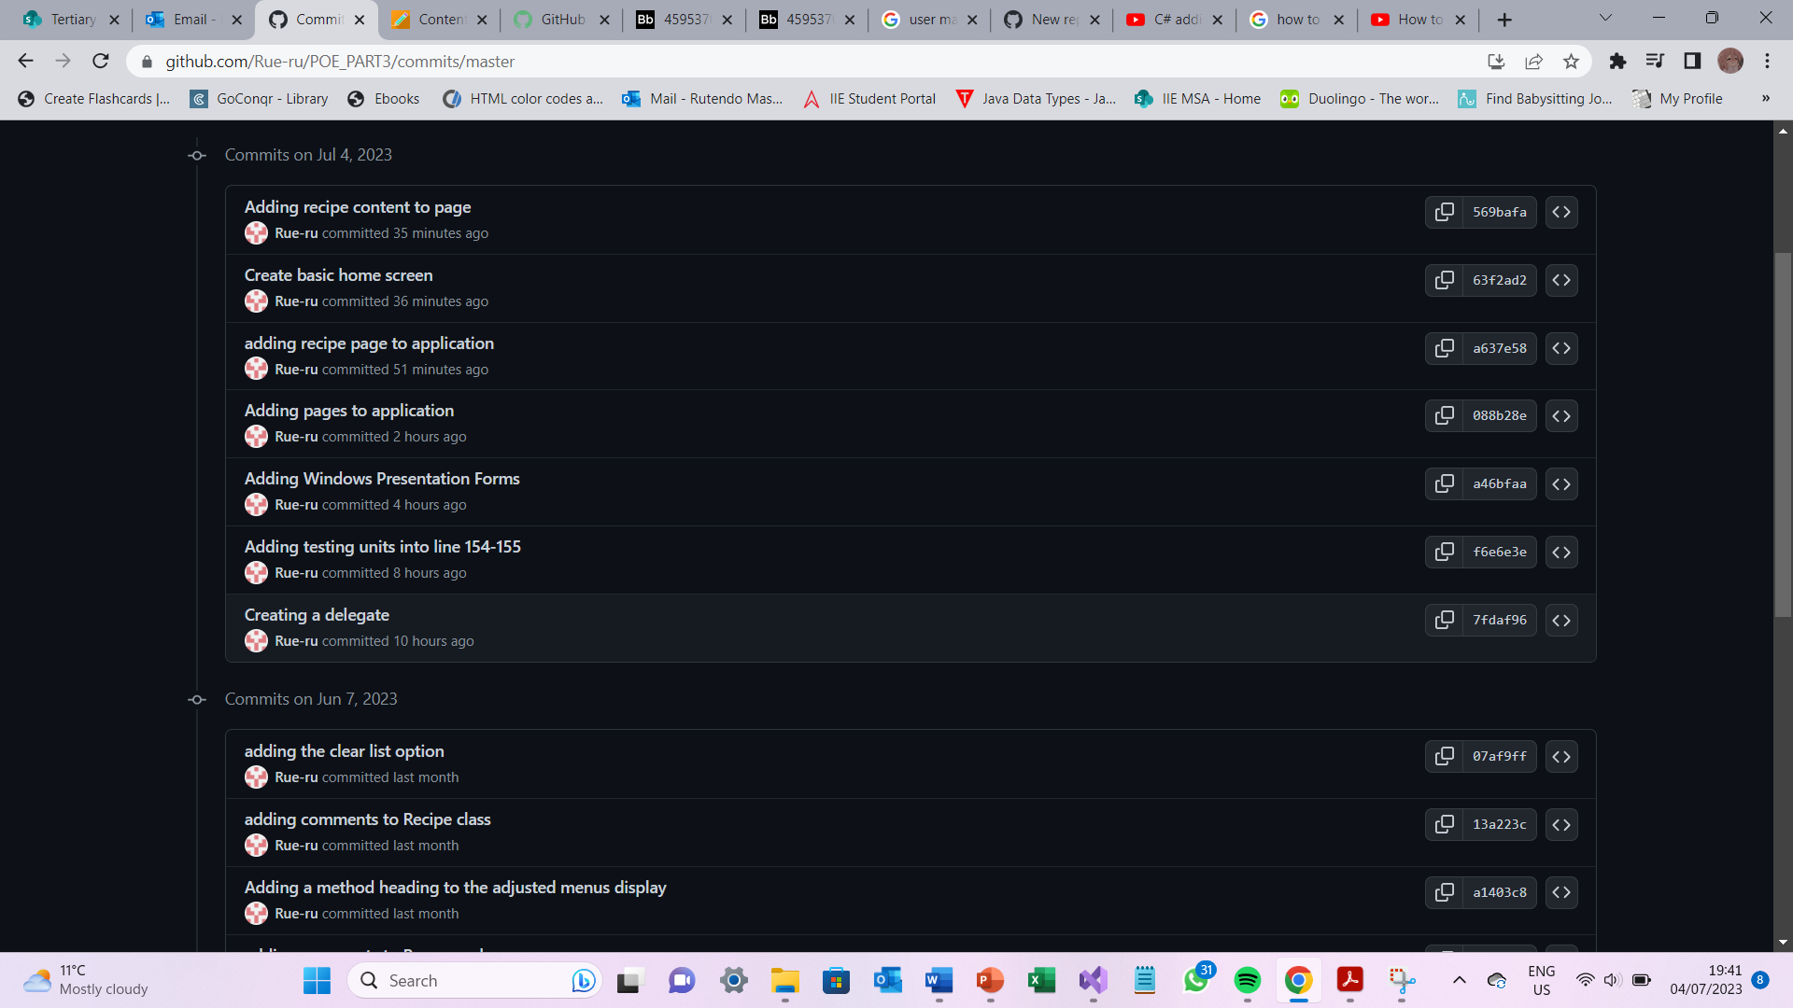

Figure 4:Commits